Client_Name

I. Multi-Touch Attribution Model:
Step 1: Define your conversion events and tracking setup

- Identify the conversion events that are important to your business, such as purchases/conversions or leads.
- Ensure you have proper tracking set up for these events on both Facebook Ads and Google Ads. This may involve installing conversion pixels or setting up conversion tracking tags.
Time required: THIS IS PROBABLY ALREADY DONE - Just need to have an understanding of this is done

Step 2: Gather data from Facebook Ads and Google Ads

- Obtain data from Facebook Ads, including the ad spend and performance metrics such as impressions, clicks, and conversions, broken down by campaigns, ad sets, and ads.
- Obtain data from Google Ads, including the ad spend and performance metrics such as impressions, clicks, and conversions, broken down by campaigns, ad groups, and keywords.
Time required: Should be done in within 1 or 2 days

Step 3: Combine and clean the data

- Merge the Facebook Ads and Google Ads data into a single dataset, ensuring that the data points align properly.
- Clean the data by removing any duplicates, inconsistencies, or irrelevant information. Verify that the data is accurate and complete.
Time required: About 1-2 weeks (depends on data - if too many discrepancies - then will have to do data engineering to fix it - if not should be done within a week)

Step 4: Implement a multi-touch attribution model

- Choose a suitable multi-touch attribution model, such as first-touch, last-touch, linear, or time decay, depending on your business goals and customer journey dynamics.
- Apply the attribution model to distribute conversions and associated revenue across the various touchpoints (campaigns, ad sets, ads, keywords) in your dataset.
Time required: Within 2 Weeks ideally, but 3 weeks with a buffer.

Step 5: Calculate the spend decomposition and optimize budget allocation

- Calculate the ad spend decomposition by attributing the spent amount across the touchpoints based on the attribution model's results.
- Analyze the performance and return on ad spend (ROAS) for each touchpoint to identify the most effective channels and campaigns.
Use optimization techniques, such as linear programming or mathematical optimization algorithms, to redistribute the budget allocation in a way that maximizes the desired outcome (e.g., revenue, conversions) within budget constraints.
Time required: Should be done within a 2 week - buffer 1 week (3 weeks)

Step 6: Visualize and report the results

- Create visualizations and reports to present the breakdown of ad spend, the optimized budget allocation, and any other relevant insights.
- Communicate the findings to stakeholders, such as marketing teams or decision-makers, to facilitate informed decision-making and strategic planning.
Time required: This should take 2-3 days

*reference image
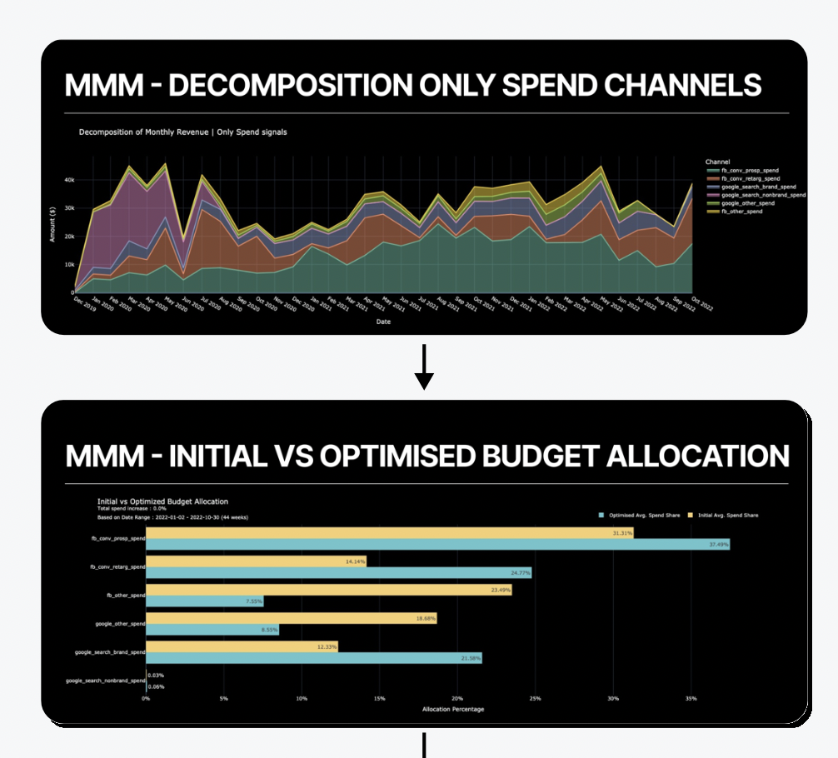

II. Optimizing Spend Predictively:
Step 1: Gather historical data

Collect historical data on ad spend, impressions, clicks, conversions, and associated revenue from both Facebook Ads and Google Ads for a significant period (e.g., several months or a year).
Ensure the data includes weekly breakdowns to capture trends and seasonality.
Time required: This step may take a few hours to collect and export the historical data from both platforms.

Step 2: Calculate ROI and MROI

Calculate the ROI for each campaign, ad set, or ad by dividing the revenue generated by the associated ad spend and expressing it as a percentage.
Calculate the MROI by factoring in additional costs and expenses related to marketing, such as creative production costs or agency fees, into the ROI calculation.
Time required: The time needed to calculate ROI and MROI depends on the complexity of your dataset and the tools you use for analysis. It may take a few hours to perform the calculations.

Step 3: Analyze weekly breakdown of ROI

Group the data by weeks and calculate the ROI for each week.
Analyze the weekly ROI trends to identify patterns, seasonality, or any significant fluctuations in performance.
Time required: This step may take a few hours to analyze the weekly breakdown and identify trends.

Step 4: Determine optimal spend levels

Identify the relationship between ad spend and ROI/MROI by analyzing historical data.
Use statistical techniques, such as regression analysis, to model the relationship and determine the optimal ad spend levels that maximize ROI or MROI.
Time required: The duration for this step can vary depending on the complexity of the analysis and the tools you use. It may take a few hours to build and validate the spend optimization model.

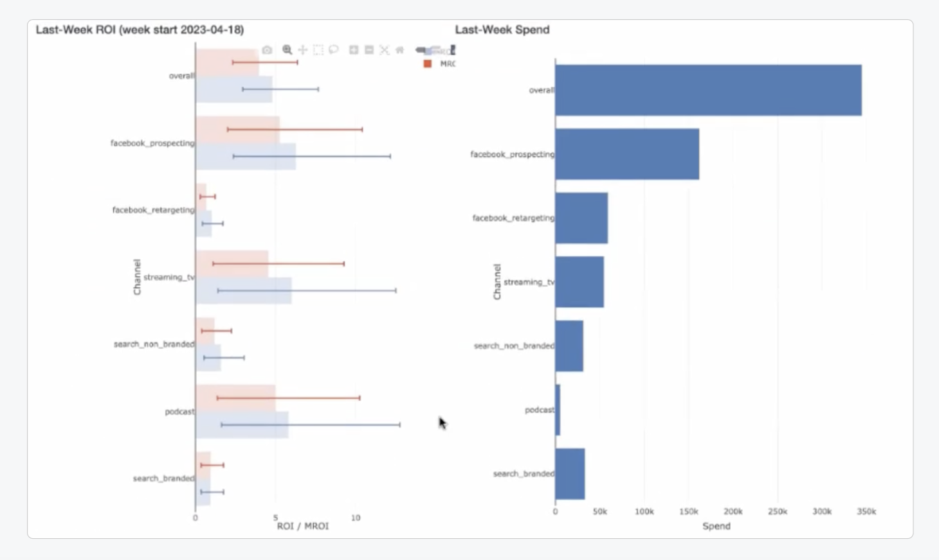

Step 5: Allocate spend for each week

Apply the spend optimization model to allocate the budget for each week, taking into account the predicted ROI or MROI for that period.
Consider budget constraints and other factors, such as seasonality or marketing goals, while allocating the spend.
Time required: The time needed for spend allocation can vary depending on the complexity of your optimization model and the volume of data. It may take a few hours to perform the allocation.

Step 6: Compare overall spend vs. spend breakdown for each week

Compare the overall ad spend against the allocated spend for each week to assess the distribution.
Analyze the spend breakdown across campaigns, ad sets, or ads for each week to evaluate the budget distribution's effectiveness.
Time required: This step may take a few hours to analyze and compare the spend breakdowns for each week.

Step 7: Monitor and iterate

Monitor the performance of your campaigns, regularly reviewing the ROI and MROI metrics.
Identify opportunities for further optimization, such as reallocating budget from underperforming channels to high-performing ones or adjusting spend levels based on changing trends or market conditions.
Time required: Monitoring and iterating the spend allocation can be an ongoing process. Allocate a few hours each week to review and refine your budget allocation strategy.

Step 8: Visualize and report the results

Create visualizations and reports that present the ROI, MROI, spend breakdown, and other relevant metrics.
Communicate the findings to stakeholders, highlighting the optimized spend allocation and the impact on ROI or MROI.
Time required: The time needed for visualization and reporting can range from a few hours to a day, depending on the complexity of the visualizations and the depth of analysis.

